Remembering those who gave their all
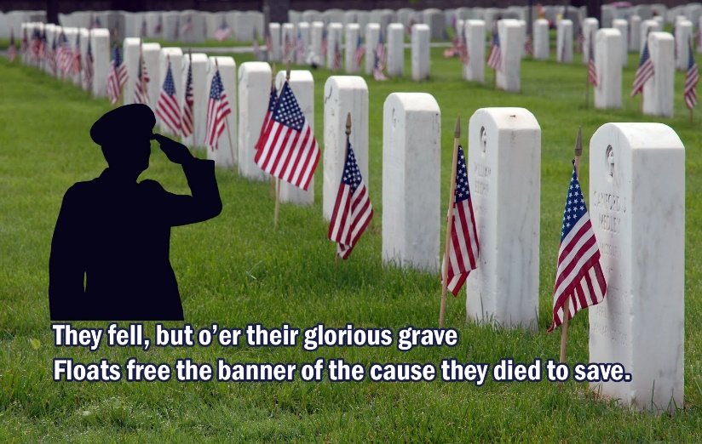

Well we are two conventions down and one to go. The Palomar Convention was longer than anticipated due to having two speakers, but it turned out great with many awards given and well deserved. Thanks again to Joye Davisson and Barbara Lerma for the job they did in getting all the arrangements completed so it came off without a hitch. Again the food was excellent. Also, the Women’s Club of Escondido was a gracious hostess.

The CFWC State convention held last weekend turned out to be a lot of fun. They tried something different this time and had workshops the mornings before the business sessions. The only problem was which workshop to choose? There were dynamic speakers at all the meetings and most dynamic. The 12 year old girl who won 1st place in the Young Musicians – Vocalist category sang an opera aria. I am not sure there was dry eye in the house. It was like Susan Boyle from Britain’s Got Talent, she overwhelmed.

Palomar District and its clubs won several awards for their Narratives:

The District won the Leadership Award for a Medium District

Vista won the following awards for a Medium Club: Leadership, Communication Advancement, Conservation Community Service, International Outreach, and Potted Tree Award.

Poway won the following awards for a Small Club: Art Community Service, Education Community Service, an Membership for Area D.

I took the 1st Place/Best of Show winners from the District Art Festival and the results were as follows:

Oil Painting – Portrait – “The Chef” Diane Jansen (Fallbrook) 1st^{d} Place
Oil Painting – Scenic - “Out the Window” Diane Jansen (Fallbrook) 2nd Place

Watercolor – Scenic - “River Barn” Annette AuBuchon (Fallbrook) 1st Place
Watercolor – Still Life - “Gentle Iris” Annette AuBuchon (Fallbrook) 2nd Place

Oil - Still Life – “Violin” Barbara Chabasian (Bonsall) 1st Place

Student Art – 5th Grade “Hand” Cash Waite (Oceanside) Participation Award
Student Art 1st Grade Stormy Seascapes” Josiah Taylor (Oceanside) Participation Award

Crafts:
Counted Cross Stitch – “Ah Choo” Puppy Bev York (Bonsall) 1st Place

General Crafts Bead Weaving Necklace Elaine Davis (Bonsall) 2nd Place

Congratulations to all on you fine work. See you again next year!

Fallbrook and Escondido were honored on Saturday might as being Federated Clubs for over 100 years.

We have one more Convention to attend. This would be the International Convention to be held in Palm Desert June 23-26. There are about ten District members going. I know there will be a work schedule as I have sent in all names of those that said they will be willing to help. Five of us will be meeting with Suzy Long on June 19 to make the 15 table decorations for the Past Presidents’ Breakfast on June 24.

I know there are installations coming up. I just want to greet the new Board members of all the clubs and thank those that are outgoing for their service and stewardship.

The Palomar Executive Board will have its first meeting in July (date not finalized). At that time, we will “meet and greet” and discuss plans for the next year. Please plan on attending *when the date is set),

I am working on the District Yearbook with Jan Imonti and also the calendar and meetings for the year. I should have it available by July and the new Yearbook will be available at the September General Meeting in Julian.

Remember to keep sending your dues in for New/Late members even though you have already sent in your Data Blanks. This could affect the final numbers for your clubs.

I have attached a flyer for a Quartermania Fundraiser. I have been asked may times about Fundraisers and this one sounds interesting to attend and observe. It Is about an hour from Fallbrook so you can estimate your time.

Have a great summer and see you in Palm Desert or in July.

Best, Myrna

