FEBRUARY 2016
Offering an opportunity to SHARE, ENCOURAGE AND COMFORT EACH OTHER
www.gfwcpalomardistrict.org
FROM THE PREZ… (Linda Bridges)

Please click here for information that was distributed to the clubs at the March 26, 2016 Board of Directors Meeting (Human Trafficking Information; 2016 Dues forms/instructions). To get in contact with our Guest Speaker, Kaye Van Nevel & Cherie Wilson from Soroptimist International of Vista, Click here to be directed to their website. Don’t forget to check out the bulletins that have been posted to the District Website since June 2014. Click here and then follow the Department, Special Project of Advancement Area of interest.

FEBRUARY LEGISLATIVE ALERT:

PETITION TO SUPPORT ARTS EDUCATION
IN HISTORIC FEDERAL EDUCATION OVERHAUL- ESEA reauthorization

Please consider signing the Petition at: https://www.votervoice.net/ARTSUSA/petitions/684/Respond
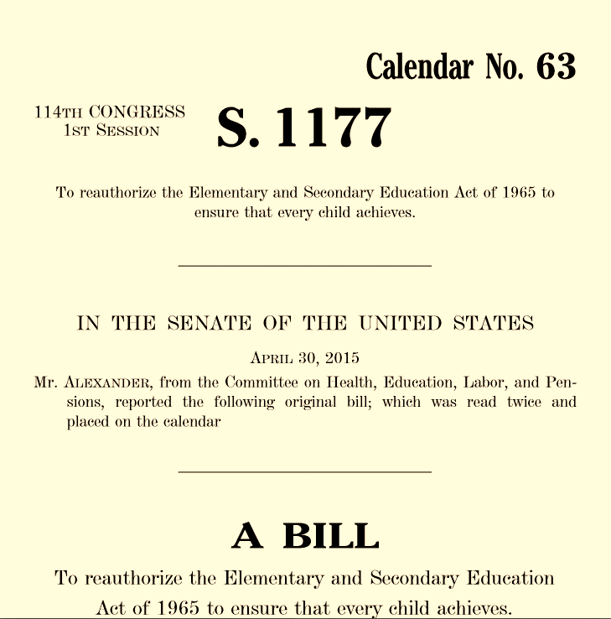
Recently, the U.S. House of Representatives and the U.S. Senate each approved legislation to replace the No Child Left Behind Act of 2001.
A select congressional conference committee has begun work to reconcile the Every Child Achieves Act (S.1177) and the Student Success Act (H.R. 5) into a final piece of legislation that President Obama will sign.
If successful, it will be the first time in 14 years that federal K-12 education policy has advanced. This is a big deal for a whole generation of students.
Combined, the two bills contain 13 arts-friendly provisions, including retaining the arts as a core academic subject which is a key legislative priority.

Keep connected to the legislative process:
Find your US Representatives- Click here
Find your State Representatives- Click here
To be connected to the GFWC Legislation Center- Click here

FROM THE DEAN’S DESK… (Myrna Binford)
'You never lose by loving. You always lose by holding back.' Barbara DeAngelis
By now you must all be done with Stage 1 of reporting…..the Narrative and on to Stage 2…the Judging. I hope we can bring home many awards for both District and Clubs. We have some amazing projects out there. I really appreciate the time you have taken to collect all the data and write the narrative. Please remember the due date back to me…February 9 (hopefully before).
We will be having the Art Festival judging February 22 at Templar’s Hall in Poway. The Chairmen have worked very hard to make this a success. Since the CWFC Convention is in Irvine this year, we will be able to drive and take more items to be judged there. Last year we flew so were limited in what we could take to the CFWC Convention. So please, knock yourselves out with you art, crafts, etc.
I hope you enjoyed the January speaker. January was Human Trafficking month so very relevant. My grandkids use the Internet and I talk to their parents about how they monitor what sites they go into. This subject has been getting a lot of attention lately. If any of you have programs that you are interested in learning more about, please let me or the new 3rd VP know. We aim to please!
I can’t believe that one month of 2016 is gone already. Have a Happy Valentine’s Day.
CALENDAR OF EVENTS
- February 9, 2016 (earlier is better!)- Report judging results due to Myrna Binford
- February 15, 2016- Deadline for Crafts & Art Pre-registration Form
- February 26-27, 2016- CFWC Board meeting in San Diego
- February 22, 2016 (Monday) - Art & Craft Judging- Poway
- March 10, 2016 (Thursday)- Palomar District Parliamentary Law Study Group Meets
- March 22, 2016 (Tuesday) – CFWC Leadership Seminar-Part 2-Oceanside
- March 22, 2016 (Tuesday)- Palomar Executive Board meeting (right after Leadership Seminar)
- April 15, 2016 (Friday)- Deadline for Palomar Convention/Art Festival Reservations
- April 26, 2016 (Tuesday) - ***Date Correction-Convention/Art Festival. (Escondido)

UPDATES TO PALOMAR WEBSITE ***Please make sure you check back monthly for updates
- Bulletins, flyers, registration forms etc.
  - Are you visiting the Palomar Website on a monthly basis for new information…especially bulletins from CFWC? Click here and you will be taken to the Bulletin webpage. Click on the Department, GFWC Special Project or Advancement Area (a date is included for most recent posting).
- New page on Palomar Website- Club Management

FROM THE TREASURER….(Shirley Ledda)
Dues are due no later than the April 26, 2016 Palomar Convention. Click here for forms.

PALOMAR YEARBOOK CORRECTION- Page 27, Mo Rafael (San Dieguito Co-President)

UPCOMING EVENTS:

February 22, 2016- Craft and Fine Art Judging
- Where: Templar Hall (Old Poway Park)- 14134 Midland Road, Poway
- Registration (Drop off entries): 10 AM
  - Morning Goodies supplied and set up by: CWONC and Valley Center (1/2 each)
- Judging: 11 AM
- Pick up Entries: Between Noon and 12:30 PM
- FORMS & INSTRUCTIONS

February 26-27, 2016- CFWC Board meeting in San Diego
Why not plant on attending one of the meal functions at the State Board meeting. Click here for meeting information. Contact Mary Sprague for individual meal prices.

March 22, 2016- (Tuesday) Gilligan, the Skipper and Mary Ann; a 3-hour Tour Towards Leadership
Where: Oceanside Woman’s Club (clubhouse) - 1606 Missouri Ave., Oceanside
- NEW- Woman’s Club of Oceanside “Farmers Market” Time: 8:30 AM to 9:30 AM
Time: 9 AM- Registration & Morning Goodies; 9:30 AM- 12:30 PM- Seminar
Cost: $5.00 per person (checks payable to Palomar District)
Registration Deadline to Linda Bridges (lin1326@aol.com) by March 15, 2016 (Tuesday)
Seminar presented by Pam Ament, CFWC Leadership Chairman
Who is invited: ALL members are invited (and encouraged) to attend!
What:
- Time Management, goal setting, stress & deadlines
- Trusting your members and fellow officers
- 10 ways to prepare for success
- Improvisation part 2
- Strengthen Membership by training new leaders
- LEADS
- Microphones and public speaking
- Going up the ladder of leadership
- Leadership Assessment and Space: The New Leadership Frontier
- Anatomy of a Meeting with Current Events
Club Assignments:
- Location, Coffee & Water- Oceanside
- Morning Goodies (1/2)- Fallbrook & Vista (Revised)

March 22, 2016- Executive Board Meeting
Where: Oceanside Woman’s Club (clubhouse) - 1606 Missouri Ave., Oceanside
Time: 12:30 PM- Just after the Leadership Seminar
- No Lunch served. If you attend the Leadership Seminar, you may want to bring a sack lunch with you.
Adjourn: No later than 1:30 PM

2016-18 EXECUTIVE BOARD *** We have an opening for Co-Dean and Assistant Treasurer
President - Myrna Binford –Fallbrook
1st VP/Dean - VIcky O'Kelly Fallbrook- (Co-Chair is open)
2nd VP Bev York Bonsall
3rd VP -- Judy Pantazo Vista
4th VP -- Sonja Hults Bonsall
Secretary - Debbie Bainbridge Julian
Treasurer -- Susan Fowler Julian
Assistant Treasurer –open-

PAPER COPIES OF CLUB ANNUAL REPORTS
One of the goals behind having our club members judge (non-competing size) reports is to offer our members the opportunity to read (In more detail) sister club projects…to glean new ideas for their own club …networking at its best. If you have no further use of the reports (after sharing) please go ahead and bring the reports back to either the March 22 Executive Board Meeting or the April 26th Convention. We will make sure that the reports are returned to the appropriate clubs.

WHAT DOES YOUR CLUB COLLECT?
A request has been made to create a list of items that our individual clubs collect for their projects. If your club would like to participate, please email Linda with the item that you would like your Federated Sister members to bring to the District meetings. We’ll keep an updated list in the Telescope…
- VISTA- Paperback books (no political, religious or cookbooks please); Children's books, grade 3 to 7; Pull tabs from soda cans ( or the like); Toiletries items all time; Men's gently used clothing especially shoes; Women's clothing appropriate for interviewing
- CWONC- collects old towels & blankets, any size; yarn; stuffing; thin quilt batting; New Baby Clothes & small toys (0-6 months)
- Bonsall- healthy snacks (fruit gummies, fruit leather, crackers, etc.), canned protein (tuna, chicken, peanut butter, etc.), toiletries (toothpaste, floss, shampoo, soap, hand sanitizer),socks in children's sizes, school supplies and cash donations are always welcome to purchase shoes and clothing. to benefit low-income students at Bonsall Elementary School-

CLUB’S- “YOU’RE INVITED”

March 10, 2016- San Dieguito and Oceanside invite you to their Fashion Show (by Chicos) and a light lunch at the Oceanside Clubhouse. Tickets are $20. Members will model fashions and there will be a variety of gift baskets available. More information to follow.

March 12, 2016- Chico’s at the Forum fundraiser to benefit both the Oceanside and San Dieguito clubs. More information to follow.

April 10, 2016- Poway Woman's Club Old-Fashioned Friendship Tea "Blossoming With Friendship"
2:00 - 4:00 PM. Donation: $20.00 Call Barbara Lerma @ 858-748-4492 or email- bblerm@aol.com

April 17, 2016- Woman’s Club of Vista 100th Anniversary Party- Click here for flyer posted on Palomar Website.

May 7, 2016- Fallbrook Woman's Club invites you to "The Sinister Sleepover"- a mystery theme pajama party and brunch. 11 AM; $25.00, 238 Mission Road. Reservations: www.fallbrookwomansclub.org

